**G-03**

| **Name** | **Roll No** |
| --- | --- |
| **Alishba** | **SE-19008** |
| **Kabeer Ahmed** | **SE-19028** |
| **Rehan Mumtaz** | **SE-19036** |
| **Sufiyan Irfan** | **SE-19037** |
| **Wajahat Ahmed** | **SE-19038** |

**Open Ended Assignment**

**Description:**

The project was all about an e-commerce store, similar to the real Amazon store. This e-commerce store is basically designed to have the real feel of buying groceries, clothes and electrical items online. We have added the functionality of payment gateway so that any customer can feel free to pay online rather than paying in cash.

The technology stack used for the web interface is:

React (front-end), for backend we use

Node-js

Express-js

Mongo-db (database)

It is hosted on firebase further, we use real-time database of firebase where we added our different assets for our websites

For payment gateway functionality, since our website is for just testing & learning purposes we do not add the real stripe instead we use the sandbox of Stripe Api.(Credentials for it is 424242424242)

Initially we carried out tests using different methodology; For front-end we tested out manually , and for backend we use POST-MAN api for checking the behavior of the server response and making sure connection is being made properly.

The following functionalities are briefed and further tested using Katalon studio (Automated Testing). For each functionality, we added the test cases, its corresponding script , Katalon report & Screenshots :

1. Sign-up

2. Sign-in

3. Edit Profile Section

4. Adding Cart/Checkout functionality

5. Payment Functionality

For testing we use our project that was clone website of Amazon store

URL of Website : <https://clone-8affc.web.app/>

**Github-url :** <https://github.com/RehanMumtaz123/AmazonClone>

**1.Functionality : Sign Up**

**Script:**

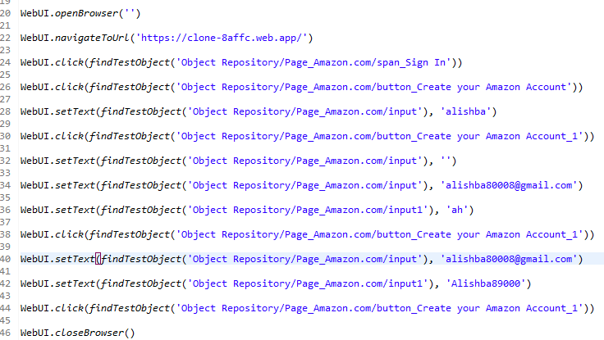

**Test Report:**

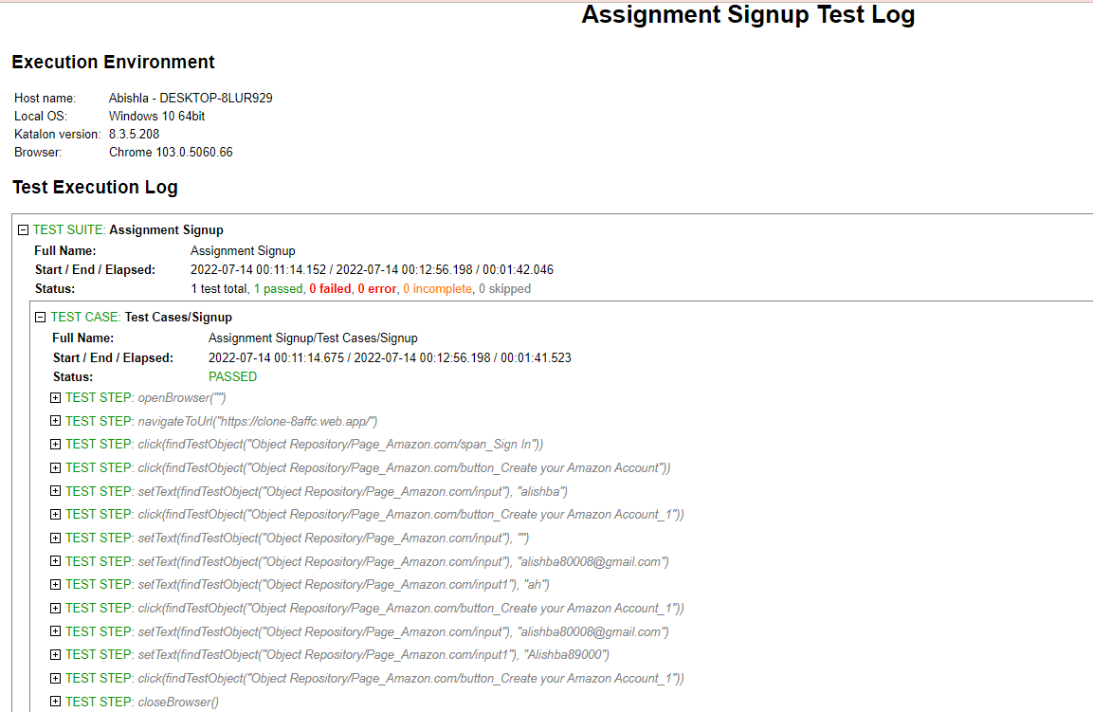

**Screenshots:**

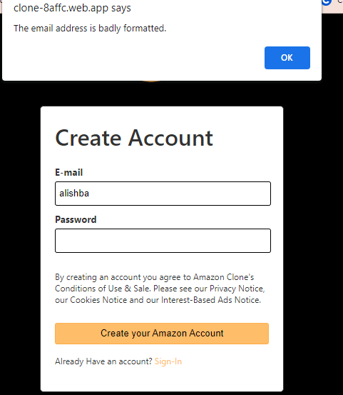

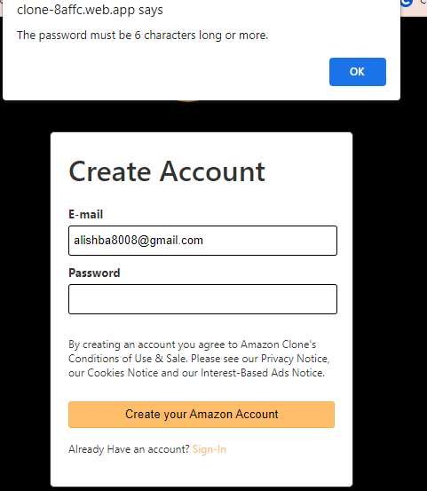

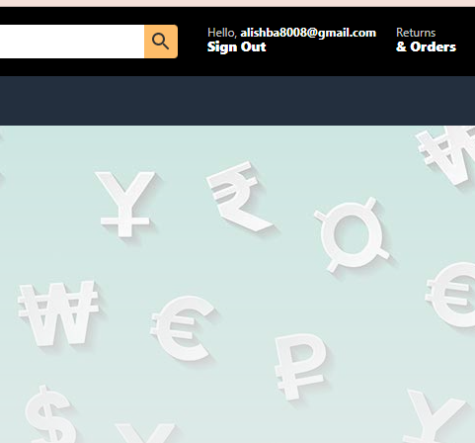

**2.Functionality : Sign In**

**Script:**

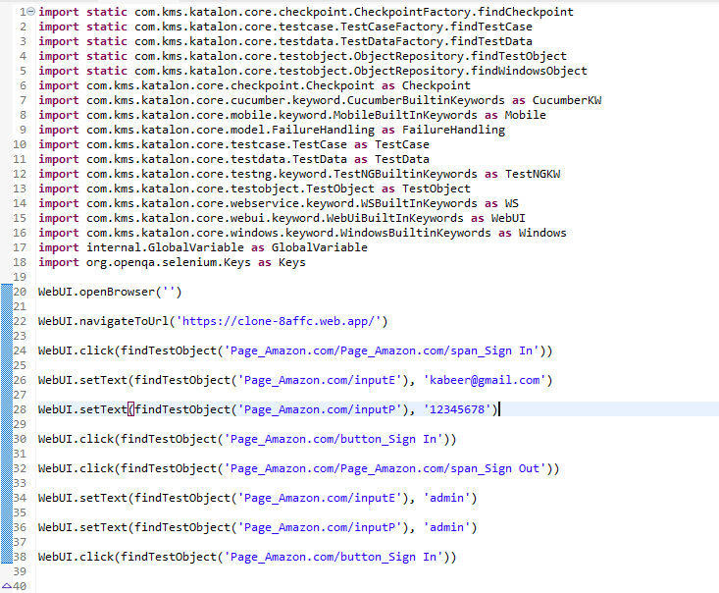

**Report:**

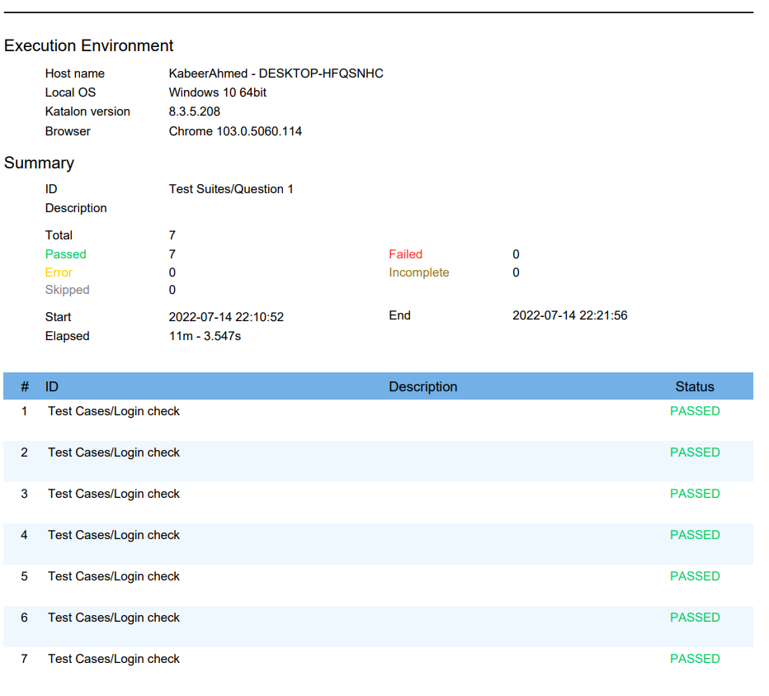

**Screenshots:**

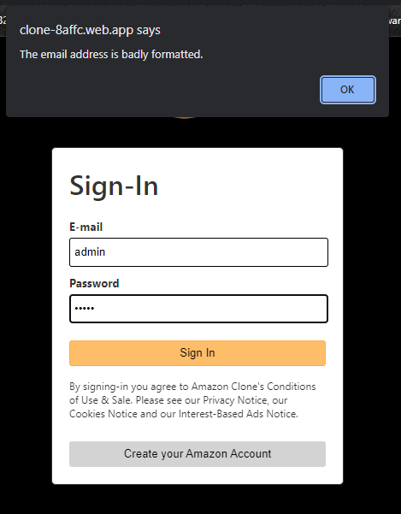

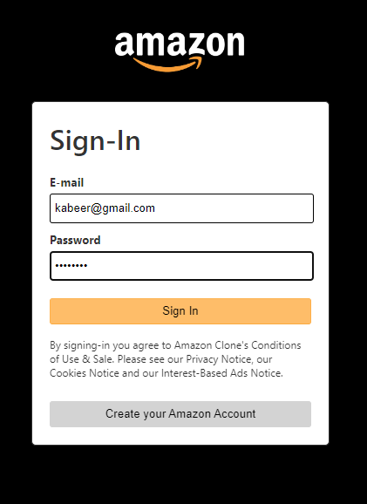

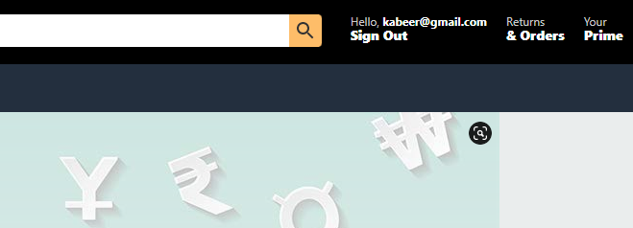

**3.Functionality : Edit Profile**

**SCRIPTS**

import static com.kms.katalon.core.checkpoint.CheckpointFactory.findCheckpoint

import static com.kms.katalon.core.testcase.TestCaseFactory.findTestCase

import static com.kms.katalon.core.testdata.TestDataFactory.findTestData

import static com.kms.katalon.core.testobject.ObjectRepository.findTestObject

import static com.kms.katalon.core.testobject.ObjectRepository.findWindowsObject

import com.kms.katalon.core.checkpoint.Checkpoint as Checkpoint

import com.kms.katalon.core.cucumber.keyword.CucumberBuiltinKeywords as CucumberKW

import com.kms.katalon.core.mobile.keyword.MobileBuiltInKeywords as Mobile

import com.kms.katalon.core.model.FailureHandling as FailureHandling

import com.kms.katalon.core.testcase.TestCase as TestCase

import com.kms.katalon.core.testdata.TestData as TestData

import com.kms.katalon.core.testng.keyword.TestNGBuiltinKeywords as TestNGKW

import com.kms.katalon.core.testobject.TestObject as TestObject

import com.kms.katalon.core.webservice.keyword.WSBuiltInKeywords as WS

import com.kms.katalon.core.webui.keyword.WebUiBuiltInKeywords as WebUI

import com.kms.katalon.core.windows.keyword.WindowsBuiltinKeywords as Windows

import internal.GlobalVariable as GlobalVariable

import org.openqa.selenium.Keys as Keys

WebUI.openBrowser('')

WebUI.navigateToUrl('https://clone-8affc.web.app/')

WebUI.click(findTestObject('Page_Amazon All Departments/a_Hello, Sign in Account Lists'))

WebUI.setText(findTestObject('Page_Amazon Sign-In/input_Email or mobile phone number_email'), 'rehanmum0@gmail')

WebUI.click(findTestObject('Page_Amazon Sign-In/input_Enter your email or mobile phone number_continue (1)'))

WebUI.setText(findTestObject('Page_Amazon Sign-In/input_Forgot your password_password'), 'helloworld')

WebUI.click(findTestObject('Page_Amazon Sign-In/input_Enter your password_signInSubmit'))

WebUI.click(findTestObject('Page_Amazon All Departments/Page_Amazon Change Name, E-mail, Password/span_Hello, cyber--or11--'))

WebUI.click(findTestObject('Page_Amazon All Departments/Page_Your Account/h2_Login security'))

WebUI.click(findTestObject('Page_Amazon All Departments/Page_Amazon Change Name, E-mail, Password/input_concat(cyber--or11, , -- -)_auth-cnep-edit-name-button'))

WebUI.setText(findTestObject('Page_Amazon All Departments/Page_Amazon Change Name, E-mail, Password/input_New name_customerName'),

'cyber')

WebUI.click(findTestObject('Page_Amazon All Departments/Page_Amazon Change Name, E-mail, Password/input_New name_cnep_1C_submit_button'))

WebUI.mouseOver(findTestObject('Page_Amazon All Departments/a_Hello, cyber Account Lists'))

WebUI.click(findTestObject('Page_Your Account/span_Sign Out'))

**Screenshots:**

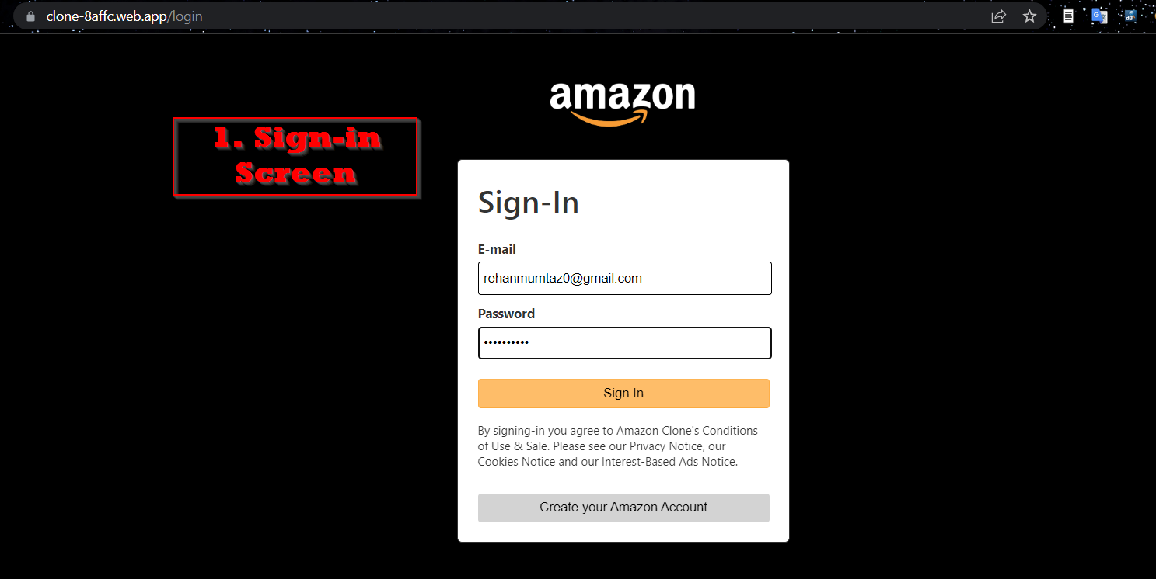

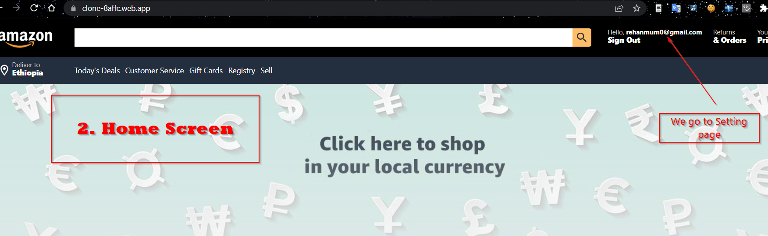

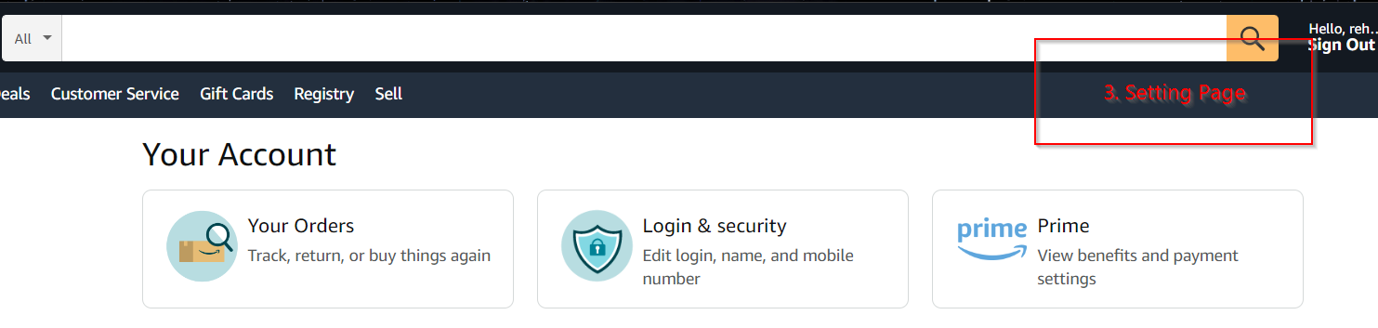

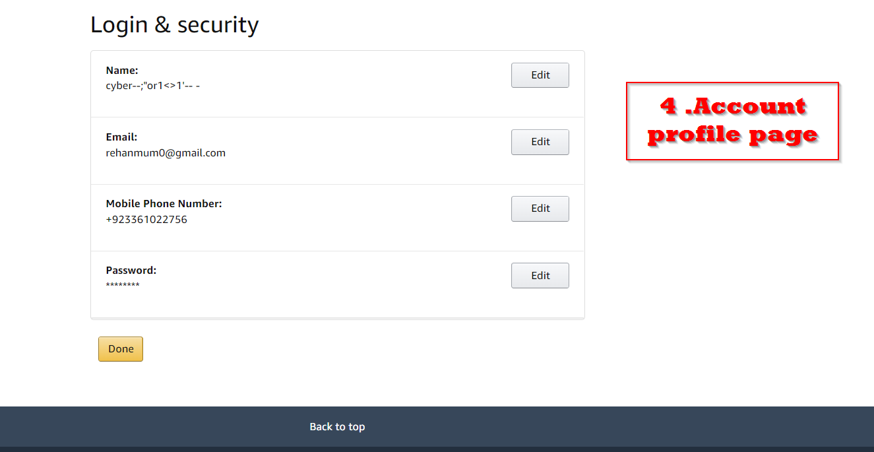

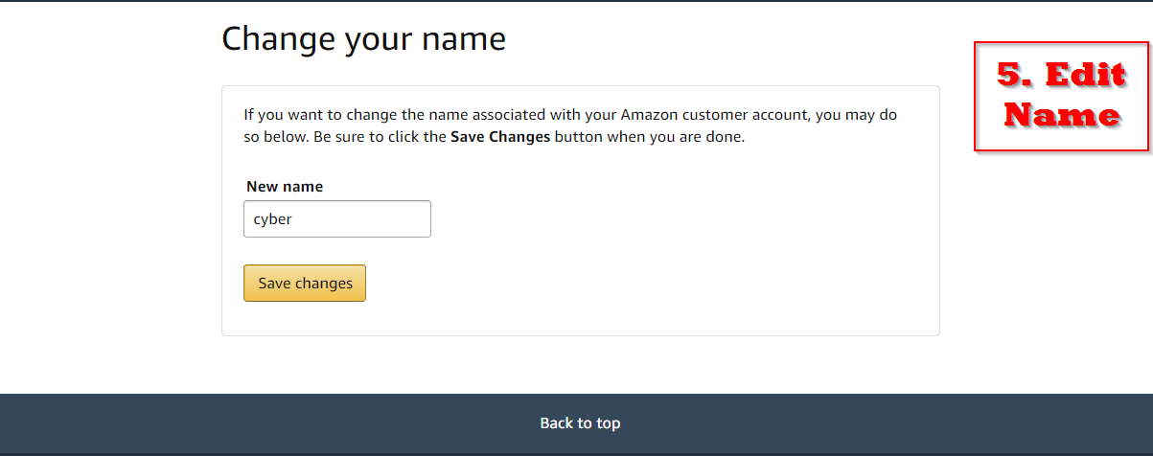

**HTML(Katalon-TestSuite HTML file report) :**

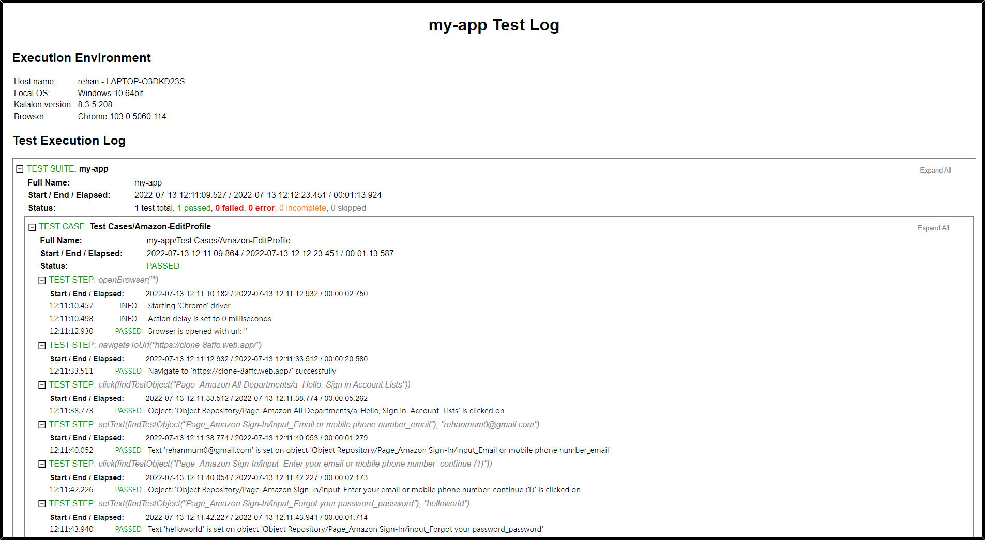

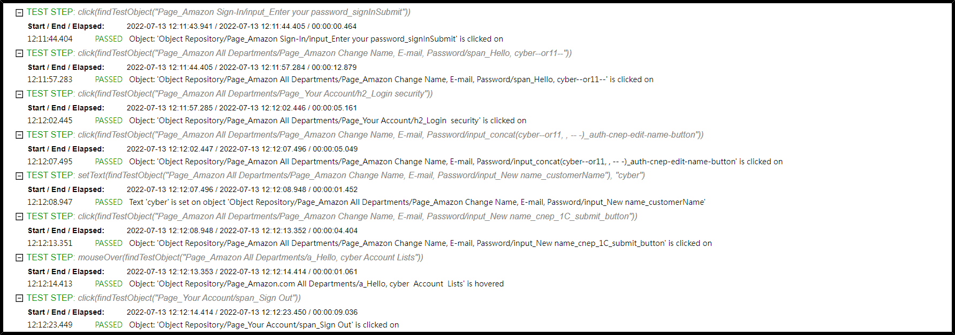

**4.Functionality : Payment Processing**

**GLOBAL VARIABLES**

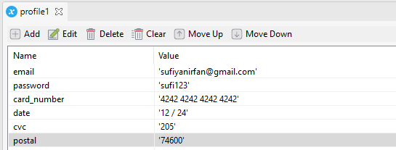

**TEST CASE**

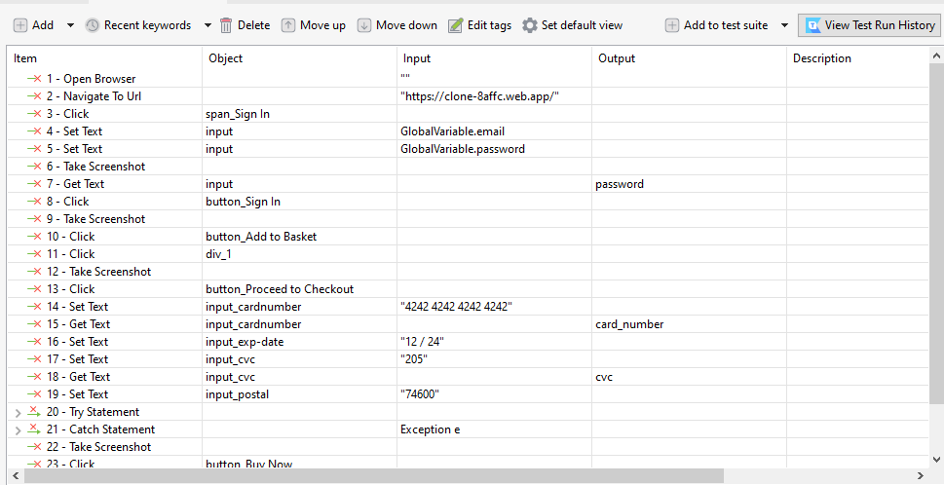

**SCRIPT**

WebUI.openBrowser('')

WebUI.navigateToUrl('https://clone-8affc.web.app/')

WebUI.click(findTestObject('Object Repository/Page_Amazon.com/span_Sign In'))

WebUI.setText(findTestObject('Object Repository/Page_Amazon.com/input'),GlobalVariable.email)

WebUI.setText(findTestObject('Object Repository/Page_Amazon.com/input'),GlobalVariable.password)

WebUI.takeScreenshot()

password=WebUI.getText(findTestObject('Object Repository/Page_Amazon.com/input'))

WebUI.click(findTestObject('Object Repository/Page_Amazon.com/button_Sign In'))

WebUI.takeScreenshot()

WebUI.click(findTestObject('Object Repository/Page_Amazon.com/button_Add to Basket'))

WebUI.click(findTestObject('Object Repository/Page_Amazon.com/div_1'))

WebUI.takeScreenshot()

WebUI.click(findTestObject('Object Repository/Page_Amazon.com/button_Proceed to Checkout'))

WebUI.setText(findTestObject('Object Repository/Page_Amazon.com/input_cardnumber'), '4242 4242 4242 4242')

card_number=WebUI.getText(findTestObject('Object Repository/Page_Amazon.com/input_cardnumber'))

WebUI.setText(findTestObject('Object Repository/Page_Amazon.com/input_exp-date'), '12 / 24')

WebUI.setText(findTestObject('Object Repository/Page_Amazon.com/input_cvc'), '205')

cvc=WebUI.getText(findTestObject('Object Repository/Page_Amazon.com/input_cvc'))

WebUI.setText(findTestObject('Object Repository/Page_Amazon.com/input_postal'), '74600')

try {

if(password.length()<=8) {

println("Password should be greater than 8 characters")

}

if(card_number.length()!=16) {

println("Card number length should be 16 characters long")

}

if(cvc.length()!=3) {

println("CVC should be 3 characters long")

}

}catch(Exception e) {

println(e)

}

WebUI.takeScreenshot()

WebUI.click(findTestObject('Object Repository/Page_Amazon.com/button_Buy Now'))

WebUI.click(findTestObject('Object Repository/Page_Amazon.com/span_Sign Out'))

WebUI.closeBrowser()

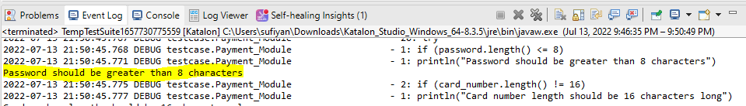

**Screenshots**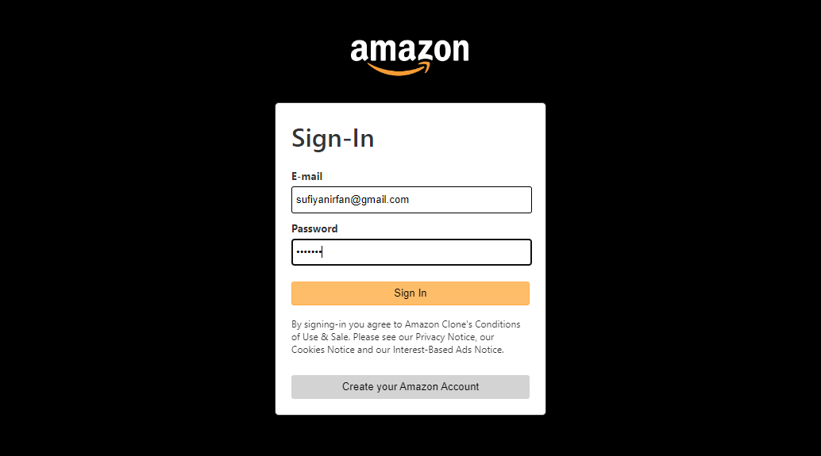 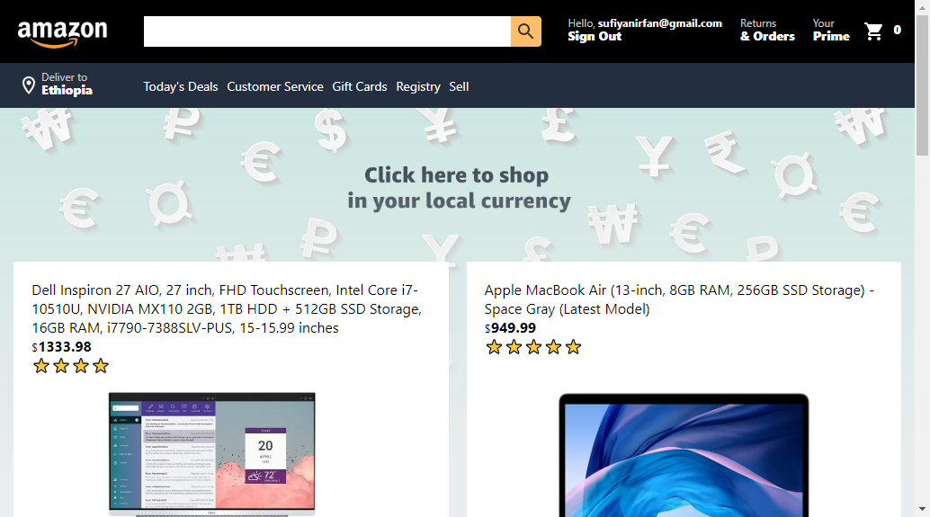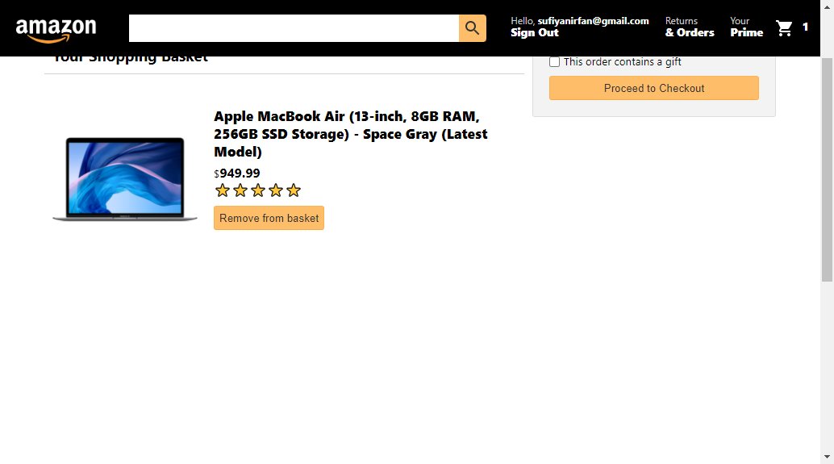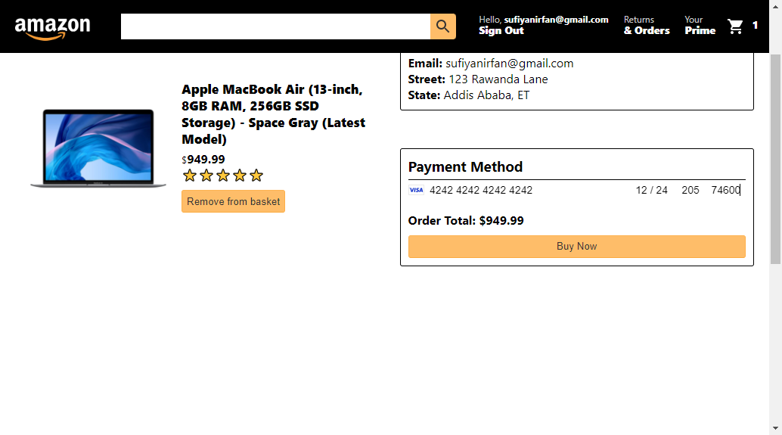

**TEST SUMMARY REPORT**

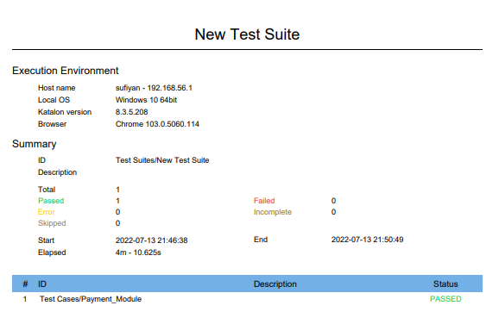

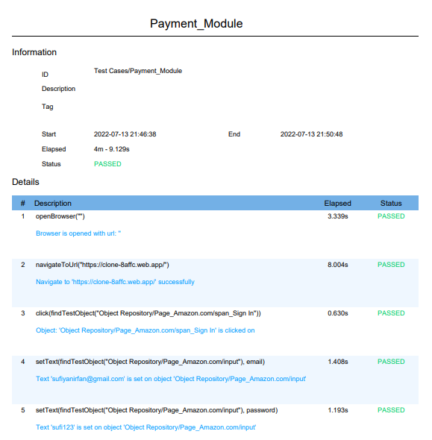

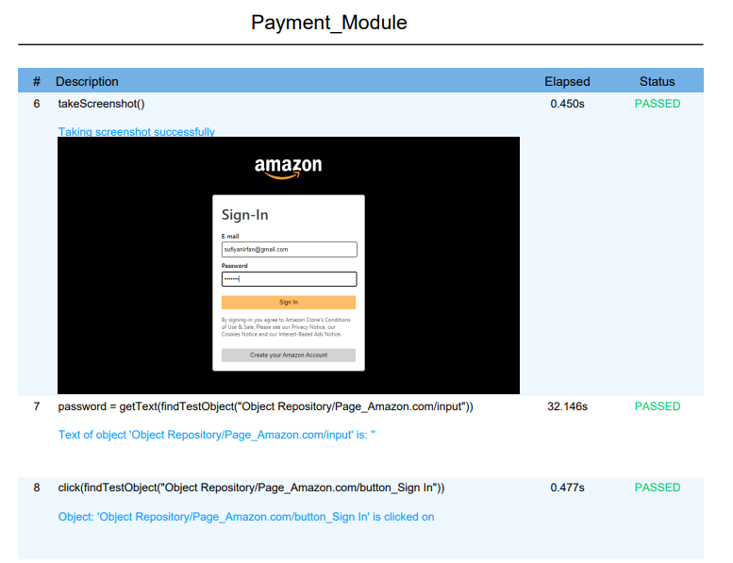

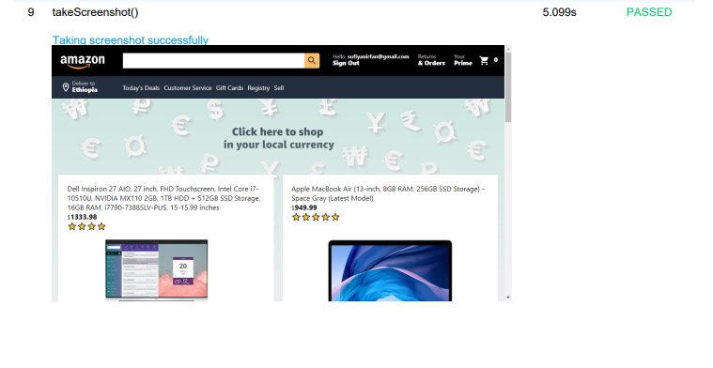

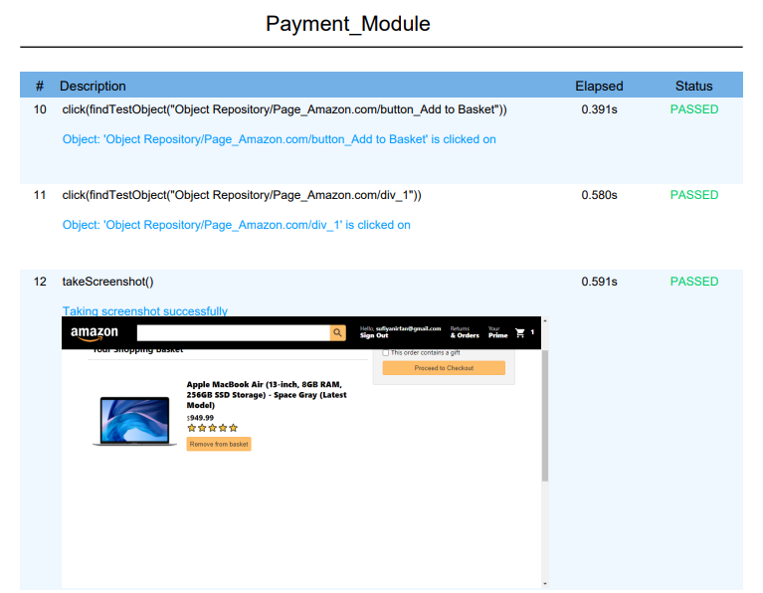

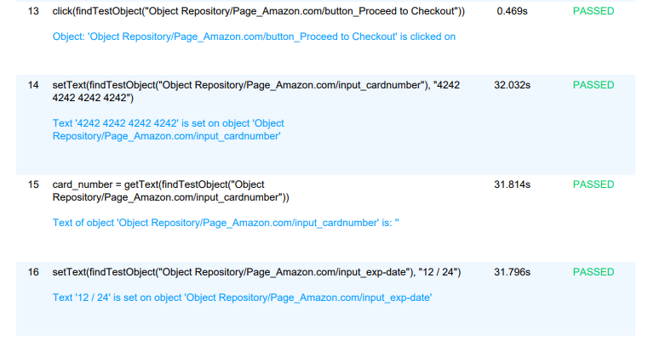

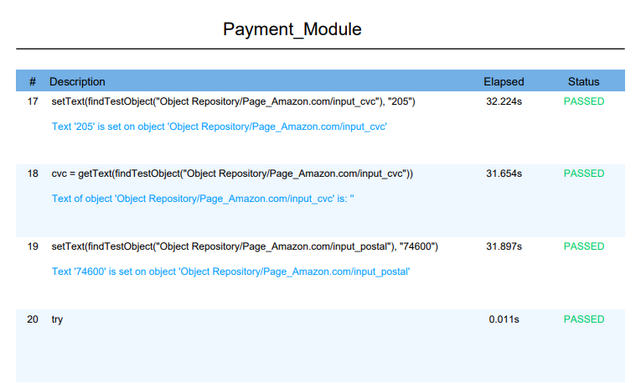

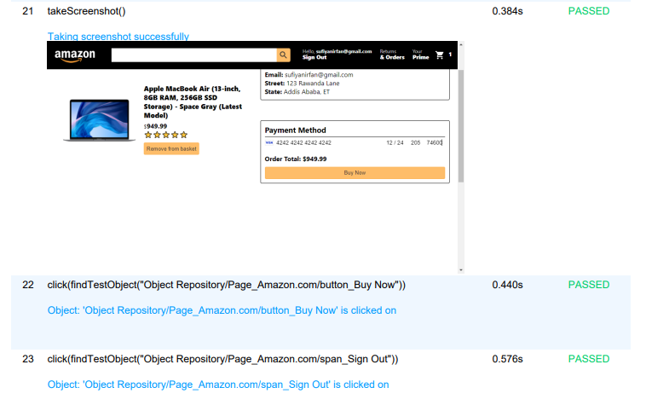

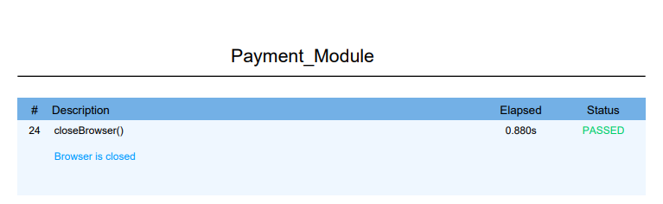

**5.Functionality: Add To Cart**

**Test Case:**

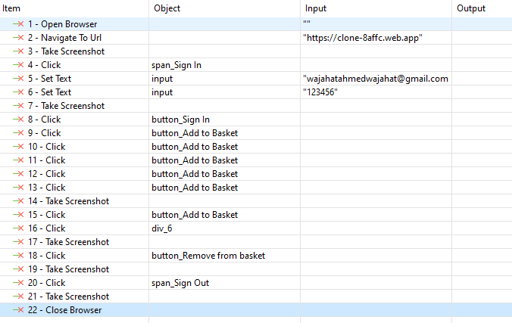

**Script:**

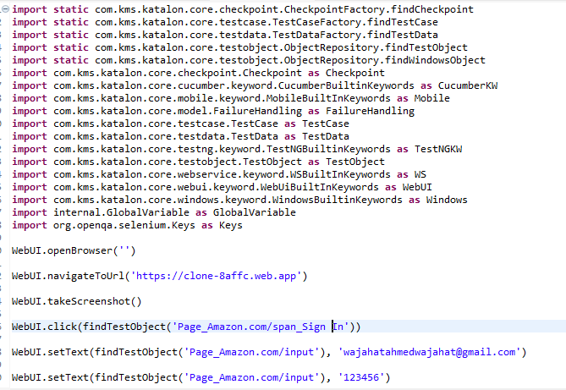

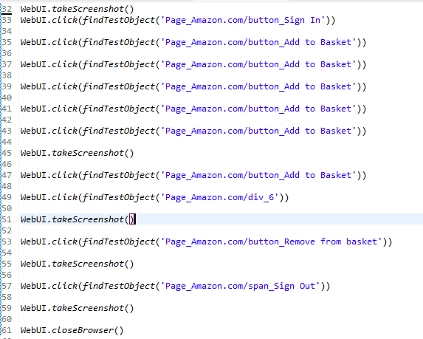

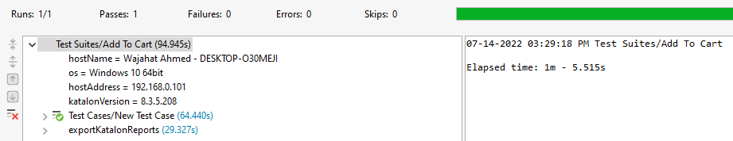

**ScreenShots:**

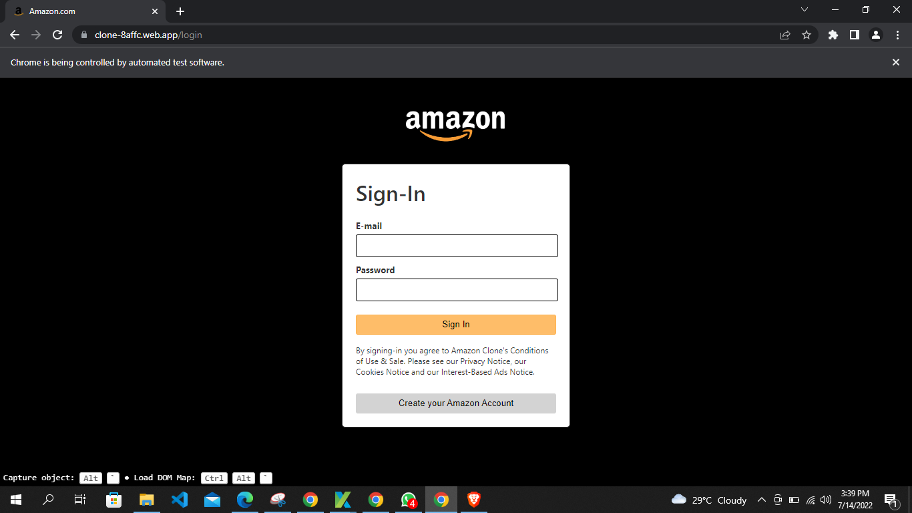

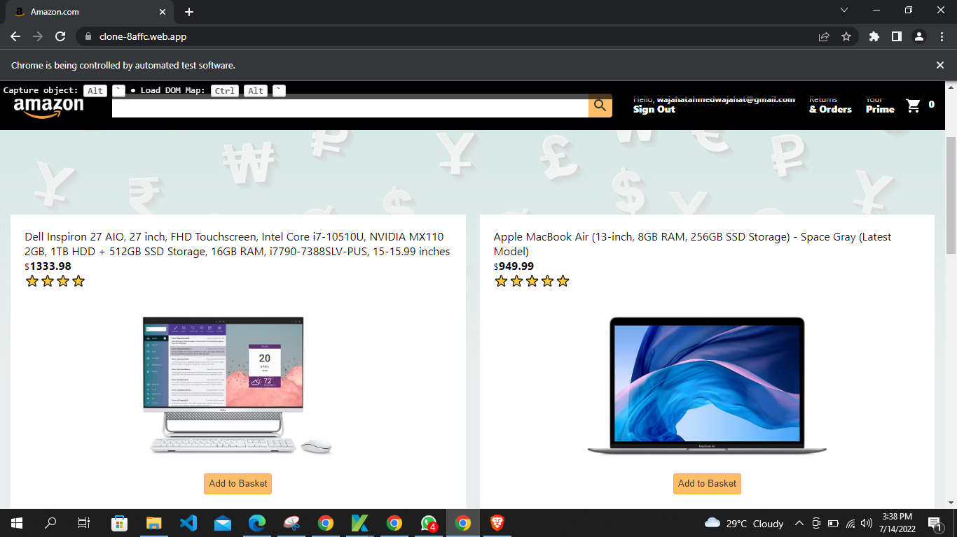

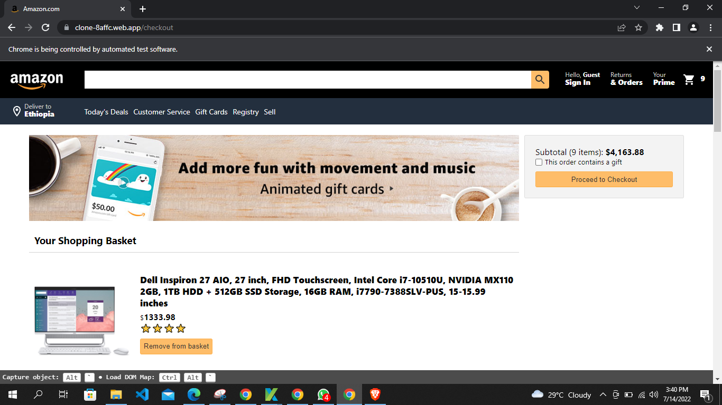

**TEST SUMMARY REPORT**

